CHAPTER 1. INTRODUCTION

1.1 PRESENT SCENARIO
For any developing country energy acts as a catalyst in the process of expansion and development of the country. India ranks sixth in the world in total energy consumption and needs to accelerate the development of the sector to meet its growth aspirations.
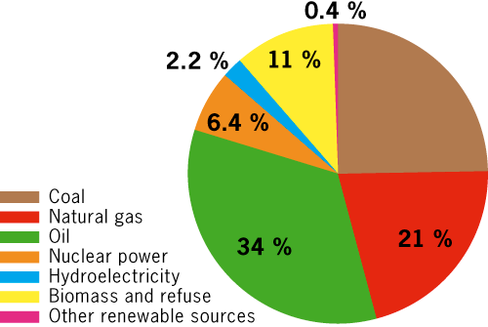

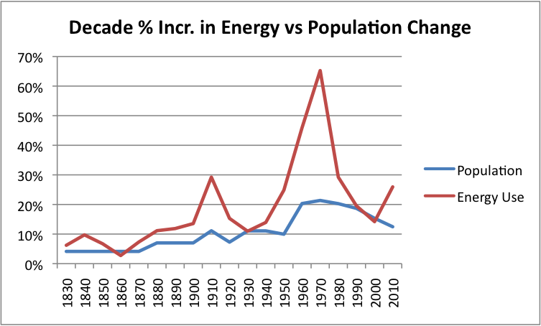
Figure 1 energy consumption worldwide

Development of Stirling engines is preceding worldwide in spite of their admittedly higher cost because of their high efficiency, particularly at part load, their ability to use any source of heat, their quiet operation, their long life and their non-polluting character. They were generally called air engines and were characterized by high reliability and safety, but low specific power.

Stirling engines have been built from the same general principles to directly pump blood, generate electricity, or directly generate hydraulic power. Many are used as heat pumps and some can be used as both heat pumps and heat engines depending upon the adjustment.
1.2 WHAT IS A STRILING ENGINE?
Stirling engine is an external combustion heat engine whereheat is provided outside the cylinder. It operates by continuous cyclic compression and expansion of air or any other gas, the working fluid, is subjected to different temperature levels so that there is a net conversion of heat energy to mechanical work. In this type of engine the working fluid is constantly held inside the cylinder. Which means the system is in thermal equilibrium. Stirling engine is distinct from other heat engines by means of regenerator through which hot gases moves from one chamber to another chamber. The main advantage of Stirling engine is that it can operate with any heat source. The efficiency of this heat engine is very high when compared to any other heat engine.

A displacer type Stirling engine has one piston and a displacer, The displacer serves to control when the gas chamber is heated and when it is cooled. This type of Stirling engine is sometimes used in classroom demonstrations. In order to run, the engine above requires a temperature difference between the top and the bottom of the large cylinder. In the case, the difference between the temperature of your hand and the air around it is enough to run the engine.
- The power piston – This is the smaller piston at the top of the engine. It is a tightly-sealed piston that moves up as the gas inside the engine expands.
- The displacer – This is the large piston in the drawing. This piston is very loose in its cylinder, so air can move easily between the heated and cooled sections of the engine as the piston moves up and down.The displacer moves up and down to control whether the gas in the engine is being heated or cooled. There are two positions:
- When the displacer is near the top of the large cylinder, most of the gas inside the engine is heated by the source and it expands. Pressure builds inside the engine, forcing the power piston up.
- When the displacer is near the bottom of the large cylinder, most of the gas inside the engine cools and contracts. This causes the pressure to drop, making it easier for the power piston to move down and compress the gas.The engine repeatedlyheats and cools the gas, extracting energy from the gas’s expansion and contraction.
CHAPTER 2. HISTORY

The Stirling Engine is one of the hot air engines. It was invented by Robert Stirling (1790-1878) and his brother James. His father was interesting in engine and he inherited it. He became a minister of the church at Scotland in 1816. At this period, he found that steam engines are dangerous for the workers. He decided to improve the design of an existing air engine. He hope it wound be safer alternative. After one year, he invented a regenerator. He called it the “Economiser” and the engine improved the efficiency. This is the earliest Stirling Engine. It is put out 100 W to 4 kW. But the internal combustion engine substituted for it quickly. The Ericsson invented the solar energy in 1864 and did some improvements for after several years. Robert’s brother, James Stirling, also played an important role in the development of Stirling engines.

Figure 2 early robert's stirling

Robert Stirling gets a patent for the economizer with an air engine incorporating it in 1817. Since the Stirling engine worked at a lower pressure, and could not cause steam burns, the danger to explode is impossible. In 1818 he built the first practical exponent of his engine, used to pump water from a quarry. The inventors sought to create a safer engine instead of steam engines at that time, whose boilers often exploded as a result of high pressure of the steam and the inadequate materials. The original patent by Reverend Stirling was called the "economizer", for its improvement of fuel-economy. The patent also mentioned the possibility of using the 6 Stirling Engine device in an engine. Several patents were later determined by two brothers for different configurations including pressurized versions of the engine. This component is now commonly known as the "regenerator" and is essential in all high-power Stirling devices.

Figure 3 engine model
Stirling engine of the second generation began in 1937.The Philips of Holland used new materials and technology to ascend a very high level. The knowledge about the heat transfer and fluid physical, which is a great significance to improving of the structure and raised the stability. Throughout World War II and by the late 1940s, Philips’ subsidiary Johan de Witt did this work. And they did the Type 10, incorporated into a generator set as originally planned The set progressed through three prototypes (102A, B, and C), with the production version, rated at 200 watts electrical output from a bore and stroke of 55x27mm, being designated MP1002CA. In 1951, the price of Stirling engine is too high for the market. It made used of radios at that time. Though the MP1002CA may have been a dead end, it represents the blooming of the modern age of Stirling Engine development. In addition to which the advent of transistor radios with their much lower power requirements meant that the market for the set was fast disappearing. Though the MP1002CA may have been a dead end, it represents the start of the modern age of Stirling engine development.
CHAPTER 3. PRESENTATION OF STIRLING ENGINES
3.1 THE STERLING CYCLE

A pressure/volume graph of the idealized Stirling cycle
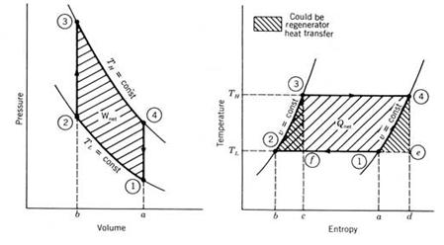
Figure 4 PV and TS diagram of a stirling engine
- Points 1 to 2, Isothermal Compression. The compression space and associated heat exchanger are maintained at a constant low temperature so the gas undergoes near-isothermal compression rejecting heat to the cold sink.

- Points 2 to 3, Constant-Volume (known as isochoric) heat-removal. The gas is passed through the regenerator, where it cools transferring heat to the regenerator for use in the next cycle.

- Points 3 to 4, Isothermal Expansion. The expansion-space and associated heat exchanger are maintained at a constant high temperature, and the gas undergoes near-isothermal expansion absorbing heat from the hot source.

- Points 4 to 1, Constant-Volume (known as is volumetric or isochoric) heat-addition. The gas passes back through the regenerator where it removes much of the heat transferred in 2 to 3, heating up on its way to the expansion space.

3.2 ENGINE CONFIGURATIONS

Mechanical configurations of Stirling engines are classified into three important distinct types: Alpha, Beta and Gamma arrangements.

These engines also feature a regenerator (invented by Robert Stirling). The regenerator is constructed by a material that conducts readily heat and has a high surface area (a mesh of closely spaced thin metal plates for example).

When hot gas is transferred to the cool cylinder, it is first driven through the regenerator, where a portion of the heat is deposited. When the cool gas is transferred back, this heat is reclaimed. Thus the regenerator “pre heats” and “pre cools” the working gas, and so improve the efficiency.

But many engines have no apparent regenerator like beta and gamma engines configurations with a “loose fitting” displacer, the surfaces of the displacer and its cylinder will cyclically exchange heat with the working fluid providing some regenerative effect

3.2.1 Alpha Stirling:
Alpha engines have two separate power pistons in separate cylinders which are connected in series by a heater, a regenerator and a cooler. One is a “hot” piston and the other one a “cold piston”.
Figure 5 alpha type
The hot piston cylinder is situated inside the high temperature heat exchanger
and the cold piston cylinder is situated inside the low temperature heat exchanger.

3.2.2 Beta Stirling:
The Beta configuration is the classic Stirling engine configuration and has enjoyed popularity from its inception until today. Stirling's original engine from his patent drawing of 1816 shows a Beta arrangement.Both Beta and Gamma engines use displacer engine has both the displacer and the piston in an in engine uses separate cylinders.
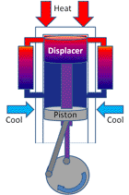
Figure 6 beta type
The purpose of the working gas at constant volume, and shuttle it between the expansion and the compression spaces through the series arrangement cooler, regenerator, and heater.
When the working gas is pushed to the hot end of the cylinder it expands and pushes the power piston. When it is pushed to the cold end of the cylinder it contracts and the momentum of the machine, usually enhanced by a flywheel, pushes the compress the gas.

3.2.3 Gamma Stirling :
A gamma Stirling is simply a beta Stirling in which mounted in a separate cylinder alongside the displacer piston cylinder, but is still connected to the same The gas in the two cylinders can flow freely between them and remains a single body.
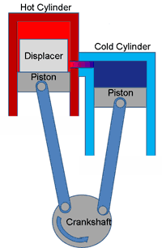
13
Figure 7 gamma type
CHAPTER 4. FUNCTIONAL DESCRIPTION

The engine is designed so that the working gas is generally compresses in the cylinder in the colder portion of the engine and expanded in the hotter portion resulting in a net conversion of heat into work. An internal Regenerative heat exchanger increases the Striling engine’s thermal efficiency compared to simpler hot air engines lacking this feature.
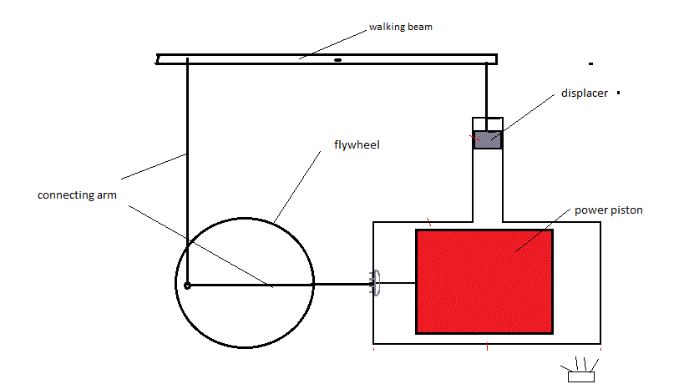
Figure 8 walking beam cycle

CHAPTER 5. ENGINE OPERATION

Since the Stirling engine is a closed cycle, it contains a fixed mass of gas called the “working fluid”, most commonly air, hydrogen or helium. In normal operation, the engine is sealed and no gas enters or leaves the engine. No valves are required, unlike other types of piston engines. The Stirling engine, like most heat engines, cycles through four main processes: cooling ,compression, heating and expansion. This is accomplished by moving the gas back and forth between hot and cold heat exchangers, often with a regenerator between the heater and cooler. The hot heat exchanger is in the thermal contact with an external heat source, such as a fuel burner, and the cold heat exchange being in thermal contact with an external heat sink, such as air fins. The gas follows the behavior described by the gas laws which describe how a gas pressure, temperature and volume are related. When the gas is heated, because it is in a sealed chamber, the pressure rises and this acts on the power piston to produce a power stroke. When the gas is cooled the pressure drops and this means that less work needs to be done by the piston to compress the gas on the return stroke, thus yielding a net power output. When one side of the piston is open to the atmosphere, the operation is slightly different. As the seated volume of working gas comes in contract with the hot side, it expands, doing work on both the piston and on the atmosphere. When the working gas contacts the cold side, its pressure drops below atmospheric pressure and the atmosphere pushes on the piston and does work on the gas. To summarize, the Stirling engine uses the temperature difference between its hot end and cold end to establish a cycle of a fixed mass of gas, heated and expanded, ands cooled and compressed, thus converting thermal energy into mechanical energy. The greater the temperature differences between the hot and cold sources, the greater the thermal efficiency. The maximum theoretical efficiency is equivalent to the Carnot cycle, however the efficiency of real engines is only a fraction of this value, even in highly optimized engines.

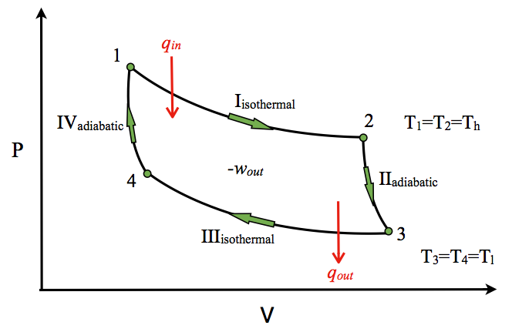
Figure 9 carnot cycle

CHAPTER 6. PRESSURIZATION

In most high power Stirling engines, both the minimum pressure and mean pressure of the working fluid are above atmosphere pressure. This initial engine pressurization can be realized by a pump, or by filling the engine from a compressed gas tank, or even just sealing the engine when the mean temperature is lower than the mean operating temperature. All of these methods increase the mass of working fluid in the thermodynamic cycle. All of the heat exchangers must be sized appropriately to supply the necessary heat transfer rates. If the heat exchangers are well designed and can supply the heat flux needed for convective heat transfer, then the engine will in a first approximation produce power in proportion to the mean pressure, as predicated by the West number and Beale number. In practice, the maximum pressure is also limited to the safe pressure of the pressure vessel. Like most aspects of Stirling engine design, optimization is multivariate and often has conflicting requirements.

CHAPTER 7. LUBRICANTS AND FRICTION

A Stirling engine and generator set with 55 KW electrical outputs. For combined heat and power applications. At high temperatures and pressures, the oxygen in air-pressurized crankcases, or in the working gas of hot air engines, can combine with the engine’s lubricating oil and explode. At least one person has died in such an explosion. Lubricants can also clog heat exchangers, especially the regenerator. For these reasons, designers prefer non-lubricated, low-coefficient of friction materials (such as rulon or graphite), with low normal forces on the moving parts, especially for sliding seals. Some designs avoid sliding surfaces altogether by using diaphragms for sealed pistons. These are some of the factors that allow stirling engines to have lower maintenance requirements and longer life than internal-combustion engines.

CHAPTER 8. COMPONENTS DESCRIPTION

The walking beam stirling engine has these components:
  - Power Piston
  - The connecting point
  - Flywheel
  - Walking Beam
  - The Displacer Piston or Displacer
Figure 10 working prototype

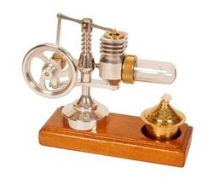

Figure 11 working prototype

8.1 SPECIFICATION

  - Weight : 700g
  - Sizes : 135mm x 50mm x 100mm
  - Material : Cylinder – glass(power),aluminium
  - Base & Other small parts – Aluminium
  - Connecting pin – brass
  - fuel: alcohol
  - flywheel of 100 g speed 120 rpm

CHAPTER 9. ENGINE PARTS SPECIFICATIONS
  - Base aluminium (135x50x100)mm
  - Vertical Stand 100 mm with base dia. of 40 mm
  - Power cylinder 20 mm dia. and 50 mm length with 15mm dia power piston(glass)
  - Displacer cylinder of 20x20 mm and 35 mm height .
  - Walking beam of 50 mm length fulcrum at the vertical stand
  - Piston rod. Brass 1/8” round rod
  - Fly wheel to walking beam rod 40 mm
  - Fly wheel support(from stand 30 mm protrusion at 30 angle)
  - Flywheel dia. of 50 mm and thickness 5 mm
  - Belt clamp of 15 mm dia. and rubber made
  - Belt of plastic nature

9.1 GENERATOR AND POWER ASSEMBLY
- Ac step generator of mini capacity.
- battery: lead acid (6 volt)
- Capacitor of 100 v and 470uf
- Rectifier
- Diode with led
- Power control board
- Switch
- Light bulbs and a multimeter
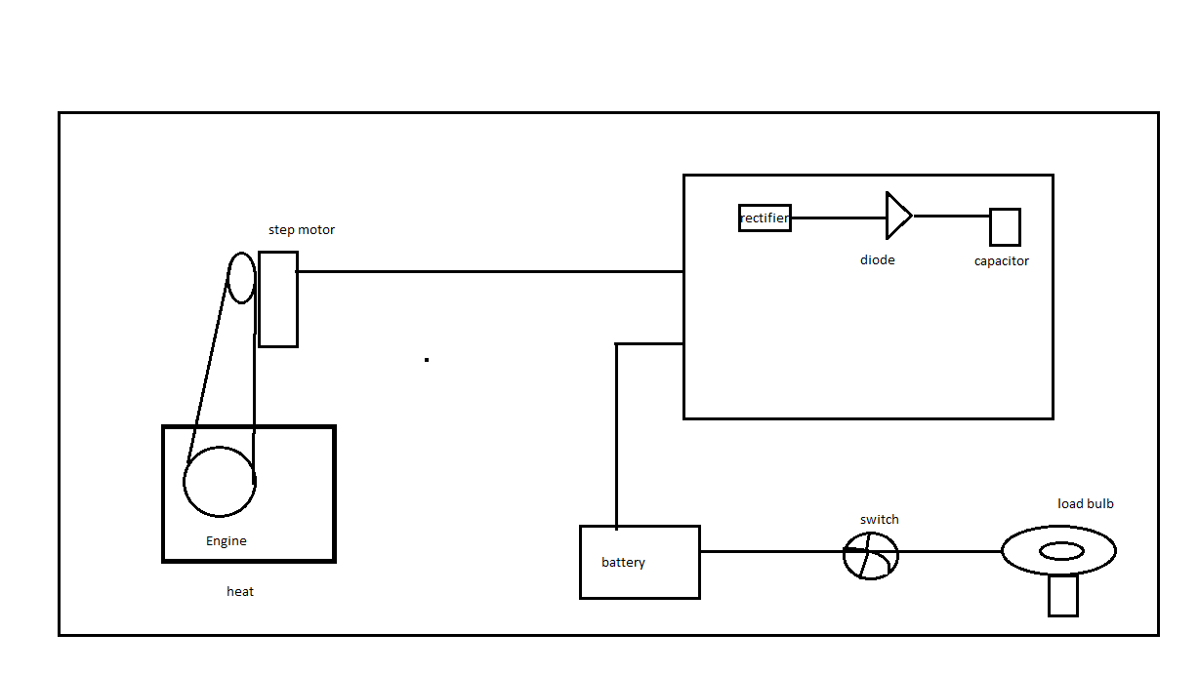
Figure 12 project setup layout

9.2 DESCRIPTION

- This engine’s power piston moves vertically and the displacer moves horizontally.

- Engine is fired by denatured alcohol burner . Heat is applied to the end of the glass cylinder . The cylinder is air-tight. Therefore air in the cylinder is permanently sealed inside the engine. This fixed amount of the air is heated & cooled , causing it to expand & contract , this driving the piston.

- As the displacer moves up , the air in the cylinder moves down to the hot side , so the air pressure inside the cylinder increase , pushing up on the piston .

- As the displacer move down , the air in the cylinder moves up to the cool side , so the pressure inside the cylinder decrease, pulling down on the piston.

9.3 EFFICIENCY

Theoritically
Stirling engine efficiency = Carnot efficiency
Unfortunately working fluid or gas is not ideal this causes the efficiency to be lower than Carnot efficiency. in fact, Stirling engine efficiency depends on
    - Temperature ratio (proportionally)
    - Pressure ratio (inversely proportional)
    - Specific heat ratio (inversely proportional
It is considered that the gas used (air, hydrogen, helium, nitrogen...) is a“perfect”gas
PV=CONSTANT
where" P" represents the pressure of gas and" V "its volume.
If the temperature of gas is introduced, this law becomes:
PV = nRT
- Qexp +Qheat – Qcool - Qcomp = Wexp – Wcomp

- Efficiency = ( Wexp - Wcomp ) / (Qexp+ Qheat )

Efficiency = 1 - T_{m} / T_{M}

A rectifier is a device which converts AC to DC. It is made up of diodes. A rectifier is generally followed by a filter circuit to improve the quality of output
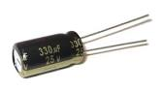
Figure 13 rectifier
Capacitor is an electronic component that stores electric charge.. The capacitor is made of 2 close conductors (usually plates) that are separated by a dielectric material

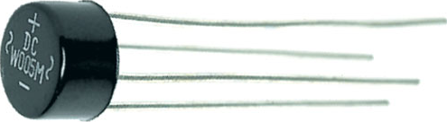
Figure 14 capacitor
An electric battery is a device consisting of two or more electrochemical cells that convert stored chemical energy into electrical energy
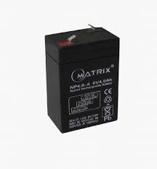
Figure 15 lead acid battery

9.4 OVERVIEW OF THE POWER CONTROL

rectifier is a device which converts AC to DC. It is made up diodes.A rectifier is generally followed by filter circuit to improve the quality of output.These two terminaled nonlinear passive elements ideally conduct only one way and hence protect the circuit as well as the source from any damage.

Diodes are widely used in rectifier circuits, limiters, communication circuits, multiplier circuits and signal clippers as well as clamper circuits.The diode that is explored in this is IN4007, which is a type of power diode. These leads are able to withstand high temperatures and provide good soldering properties.

9.5 CONSTRUCTION
- JB Weld can be applied with a toothpick or Popsicle stick. Red RTV can be used to seal and glue some parts on the outside of the Stirling engine. It’s cheaper and dries faster than J-B Weld, but it’s not as strong. Do not use RTV on the displacer because it has a high friction coefficient and will cause the displacer to drag if it rubs against the side of the pressure vessel. Use drops of superglue or slivers of tape to temporarily hold parts in place while epoxy sets.
- Use JB Weld to attach the pressure vessel bottom to the ring stand.
- Insert the displacer into pressure vessel. Place the top on the pressure vessel and gently push the top into the vessel. Note that the straight pin should protrude at least ½” form the hole in the top. Verify that the displacer moves smoothly inside the pressure vessel when the displacer rod (straight pin) is moves up and down. Glue the top onto the vessel with RTV. This joint must be air-tight. Once the glue has dried, bend 5/16” inch of the end of the straight pin to a 90 degree angle. Be careful not to bend the portion of the pin that must pass through the hole in the top of the vessel. Optionally, you can instead use JB Weld to attach a shorter piece of a straight pin the top of the displacer rod to make a 5/16” horizontal rod.
- Fit the flywheel CD onto the crank. You can attach a wire nut to the end of the crankshaft and wrap electrical tape around it until it just fits into the hole in the CD. Turn the crankshaft/flywheel and eliminate as much wobble as possible.
- Install the crankshaft in the support holes. With the crankshaft in place, use RTV to attach the supports to the side of the pressure vessel so that the ¼” holes in the pressure vessel and one of the crankshafts supports line up. Note that the crankshaft is correctly oriented with respect to the ¼” hole in the pressure vessel as shown on the last page of this PDF file.
- Use a knife or dremel tool to shape the smaller end to the ¾” to ½” PVC Elbow so that it saddles the side of the pressure vessel over the ¼” hole. The ¾” end of the PVC elbow should point up. Note that the outer diameters of the PVC elbow are actually 1-1/4” and 1” respectively. Also note a ¾” to ¾” PVC elbow can also be used instead. Use RTV to attach the PVC elbow over the ¼” hole in the crankshaft support and pressure vessel bottom.
- Install the displacer connecting rod (aluminum wire or paperclip wire) between the crankshaft and the 5/16” horizontal part of the displacer rod. (See The Recent Past’s stretch). Adjust the wire so that when the crank is turned, the displacer comes close to the top and bottom of the pressure vessel but does not touch. Tape a washer or coin to the side of the flywheel to counteract the weight of the displacer. Turn the crank and adjust the location of the washer until the crank turns smoothly (i.e. the weight of the washer counterbalances the weight of the displacer). If a point can’t be found, a larger washer may be needed.
- Cut a rubber diaphragm from a helium quality balloon. The diaphragm should be cut from a spherical portion of the balloon so that it is dish shaped. The diaphragm should be air-tight and loosely fitted, so that it does not stretch through the entire motion of the crank. At the top and bottom of the stroke the diaphragm should be slightly taut. The dish shape of the diaphragm should help achieve the range of motion without stretching the diaphragm. It is important that the diaphragm not resist (by stretching) movement of the engine. Use a tight rubber band around the PVC opening if the balloon does not fit tightly. Optionally, apply superglue to the rim of the PVC elbow and press the rubber diaphragm onto the end cap.
- Install the power diaphragm connecting rod per TheRecentPast’s stretch. Note the orientation of the foot. Attach a square of rubber balloon to the top of the connecting rod foot with superglue. Attach the covered connecting rod foot to the diaphragm with a drop of superglue. Verify that the end of the wire is turned up and will not stick into the diaphragm. The diaphragm should movie into and out of the end-cap when the crank is turned but should not stretch.
- 1/8” strips of aluminum cans be wrapped around the crankshaft to keep it and the connecting rods from sliding form side to side. Here is an example engine with these strips.
- Optional: Fasten the legs of the ring stand.

CHAPTER 10. STIRLING ENGINE OPERATION

- The engine should run off the heat from a tea light candle, assuming the flame is as intense as an average candle. Light and place the candle under the pressure vessel. After 30 seconds or so, gently spin the crank in the direction in which the displacer rises before the diaphragm.

- This engine will rotate at 120 RPM or greater depending on the heat produced by the candle flame. If the flame is too small, the engine will not work. Cooling the top with water or ice may help, just don’t let the water get inside the engine. The more water put on top of the vessel, the cooler it will stay and the faster the engine will run. A collar can be built around the displacer rod to keep water out of the vessel and the sides of the vessel top can be built up with a larger collar to make a space for holding water on top of the vessel.

- The displacer, pressure vessel, diaphragm, etc. have to be air tight. There should only be minuscule air leakage around the pinhole when the engine operates. You can check it by putting a drop of oil on the pin hole. There should be a few small bubbles formed when the displacer moves up and down.

- Minimize all binding and friction using drops of oil. The flywheel should turn freely. Verify that the flywheel is balanced with the displacer connected to the crankshaft and the diaphragm disconnected. The displacer should not hit the top or bottom of the pressure vessel. The diaphragm should not stretch or tighten during operation. It should “pop” in and out.

CHAPTER 11. REGENERATOR
In a Stirling engine, the regenerator is an internal heat exchanger and temporary heat store placed between the hot and cold space such that the working fluid passes through it first in one direction then the other. Its function is to retain within the system that heat which would otherwise be exchanged with the environment at temperatures intermediate to the maximum and minimum cycle temperatures, thus enabling the thermal efficiency of the cycle to approach the limiting Carnot efficiency defined by those maxima and minima.

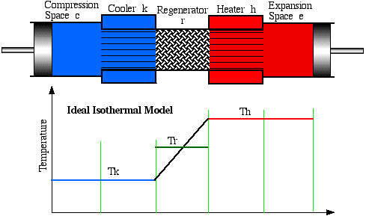
Figure 16 regenerator

regenarator connect the hot and cold side of the cylinder.this helps in reaching a thermal equilibrium inside the system which is also responsible for the cyclic compression and expansion of piston thus leading to the engine working.

CHAPTER 12 HEAT EXCHANGERS

As a consequence of closed cycle operation the heat that drives a Stirling engine must be transmitted to and from the working fluid by heat exchangers. In small, low power engines these may simply consist of the walls of the hot and cold spaces but where larger powers are required a greater surface area is needed to facilitate the transfer of sufficient heat. Typical implementation is internal and external fins or multiple small bore tubes. As with the regenerator, designing Stirling engine heat exchangers is a balance high heat transfer with low viscous pumping losses and low dead space.

BILL OF MATERIALS

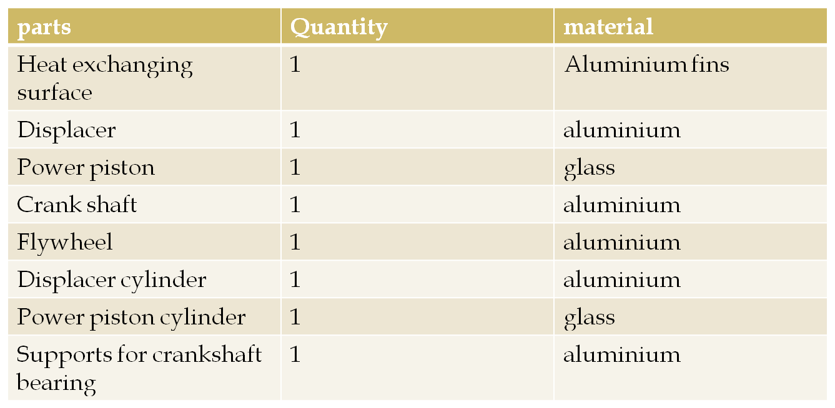
Figure 17 bill of materials

CHAPTER 13. TWENTEENTH CENTURY REVIVAL

During the early part of the twentieth century the role of the Stirling engine as a “domestic motor” was gradually taken over by the electric motor and small internal combustion engines. Until by the late 1930’s it was largely forgotten, only produced for toys and a few small ventilating fans. At this time Philips was seeking to expand sales of its radios into areas where electricity was unavailable and the supply of batteries uncertain. Philips management decided a group of engineers at the company’s research lab in Eindhoven to evaluate alternatives.

CHAPTER 14. ANALYSIS

In contrast to internal combustion engines, Stirling has the potential to use renewable heat sources more easily, to be quieter, and to be more reliable with lower maintenance. They are preferred for applications that value these unique advantages, particularly if the cost per unit energy generated ($/kWh) is more important than the capital cost per unit power ($/kW). On this basis, Stirling engines are cost competitive up to about 100Kw.

Compared to an internal combustion engine of the same power rating, Stirling engines currently have a higher capital cost and are usually larger and heavier. Their lower maintenance requirements make the overall energy cost comparable. The thermal efficiency is also comparable (for small engines), ranging from 15% to 30%. For applications such as micro-CHP, a Stirling engine is often preferable to an internal combustion engine.

Other applications include water pumping, astronautics, and electrical generation from plentiful energy sources that are incompatible with the internal combustion engine, such as solar energy, and biomass such as agricultural waste and other waste such as domestic refuse. Stirlings have also been used as a marine engine in Swedish Gotland class submarines. However, Stirling engines are generally not price-competitive as an automobile engine, due to high cost per unit power, low power density and high material costs.

CHAPTER 15. ADVANTAGES OF STIRLING ENGINES

- They can run directly on any available heat source, not just one produced by combustion, so they can run on heat form solar, geothermal, biological, nuclear sources or waste heat from industrial processes.

- A continuous combustion process can be used to supply heat, so most types of emissions can be reduced.

- Most types of Stirling engines have the bearing and seals on the cool side of the engine, and they require less lubricant and last longer than other reciprocating engine types.

- The engine mechanisms are in the some ways simpler than other reciprocating engine types. No values are needed, and the burner system can be relatively simple.

- A Stirling engine uses a single-phase working fluid which maintains an internal pressure close to the design pressure, and thus for a properly designed system the risk of explosion is low. In comparison, a steam engine uses a two-phase gas/liquid working fluid, so a faulty relief valve can cause an explosion.

- Operates at relatively low pressure and thus are much safer than typical steam turbines

- Less manpower needed to operate any type of commercial Stirling engine.

- Heat is external and the burning of a fuel-air mixture can be more accurately controlled .

15.1 DISADVANTAGES OF STIRLING ENGINES

15.1.1 Size and cost issues
- Stirling engine designs require heat exchangers for heat input and for heat output, and these must contain the pressure of the working fluid, where the pressure is proportional to the engine power output. In addition, the expansion-side heat exchanger is often at very high temperature, so the materials must resist the corrosive effects of the heat source, and have low creep (deformation). Typically these material requirements substantially increase the cost of the engine. The materials and assembly costs for a high temperature heat exchanger typically accounts for 40% of the total engine cost.
- All thermodynamic cycles require large temperature differentials for efficient operation. In an external combustion engine, the heater temperature always equals or exceeds the expansion temperature. This means that the metallurgical requirements for the heater material are very demanding. This is similar to a Gas turbine, but is in contract to an Otto engine or Diesel engine, where the expansion temperature can far exceed the metallurgical limit of the engine materials, because the input heat source is not conducted through the engine, so engine materials operate closer to the average temperature of the working gas.
15.1.2 Power and Torque Issues Stirling engines, especially those that run on small temperature differentials, are quite large for the amount of power that they produce (i.e., they have low specific power). This is primarily due to the heat transfer coefficient of gaseous convection which limits the heats flux that can be attained in a typical cold heat exchanger to about 500 W/(m-K), and in a hot heat exchanger to about 500-5000 W/(m-K). Compared to internal combustion engines, this makes it more challenging for the engine designer to transfer heat into and out of the working gas. Increasing the temperature differential and/or pressure allows Stirling engines to produce more power, assuming the heat exchangers are designed for the increases heat load, and can deliver the convected heat flux necessary.

15.1.3 Gas Choice Issues

The used gas should have a low heat capacity, so that a given amount of transferred heat leads to a large increase in pressure. Considering this issue, Helium would be the beat gas because of its very low heat capacity. Air is a viable working fluid, but the oxygen in a highly pressurizes air engine can cause fatal accidents caused by lubricating oil explosions. Following one such accident Philips pioneered the use of other gases to avoid such risk of explosions.
- Hydrogen’s low viscosity and high thermal conductivity make it the most powerful working gas, primarily because the engine can run faster than with other gas. However, due to hydrogen bonding, and given the high diffusion rate associated with this low molecular weight gas, particularly at high temperatures, H2 will leak through the solid metal of the heater. Diffusion through carbon steel is too high to be practical, but may be acceptably low for metals such as aluminum, or even stainless steel. Certain ceramics also greatly reduce diffusion. Hermetic pressure vessel seals are necessary to maintain pressure inside the engine without replacement of lost gas. For HTD engines, auxiliary systems may need to be added to maintain high pressure working fluid. These systems can be a gas storage bottle or a gas generator. Hydrogen can be generated by electrolysis of water, the action of steam on red hot carbon-based fuel, by gasification of hydrocarbon fuel, or by the reaction of acid on metal. Hydrogen can also cause the embrittlement of metals. Hydrogen is a flammable gas, which is a safety concern, although the quantity used is very small, and it is arguably safer than commonly used flammable gases.
15.2 APPLICATIONS

- Solar power generation.
- Stirling cryocoolers.
- Heat pump.
- Marine engines.
- Nuclear power.
- Automotive engines.
- Electric vehicles.
- Aircraft engines.

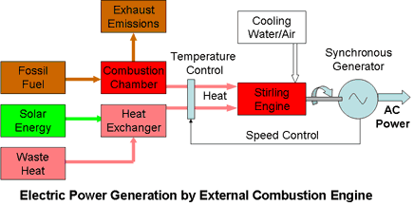
Figure 18 applications

CHAPTER 16. Assembly Diagram

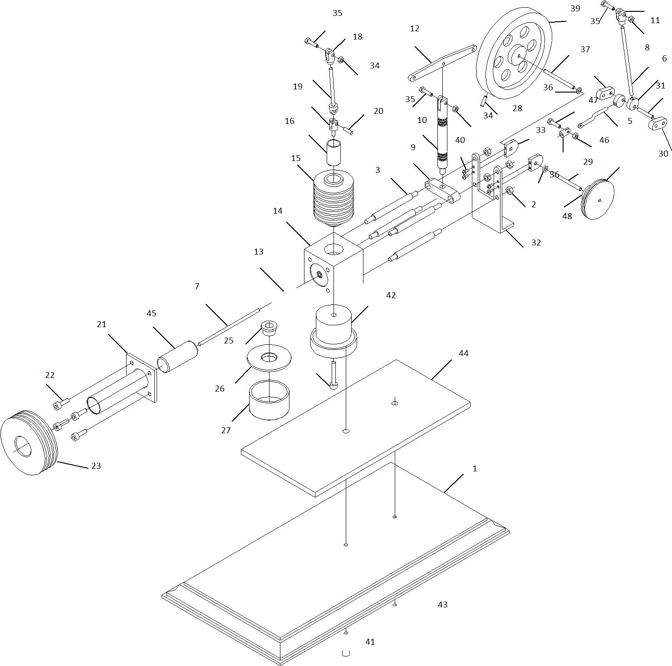
Figure 19 assembly diagram

16.1 Components reference
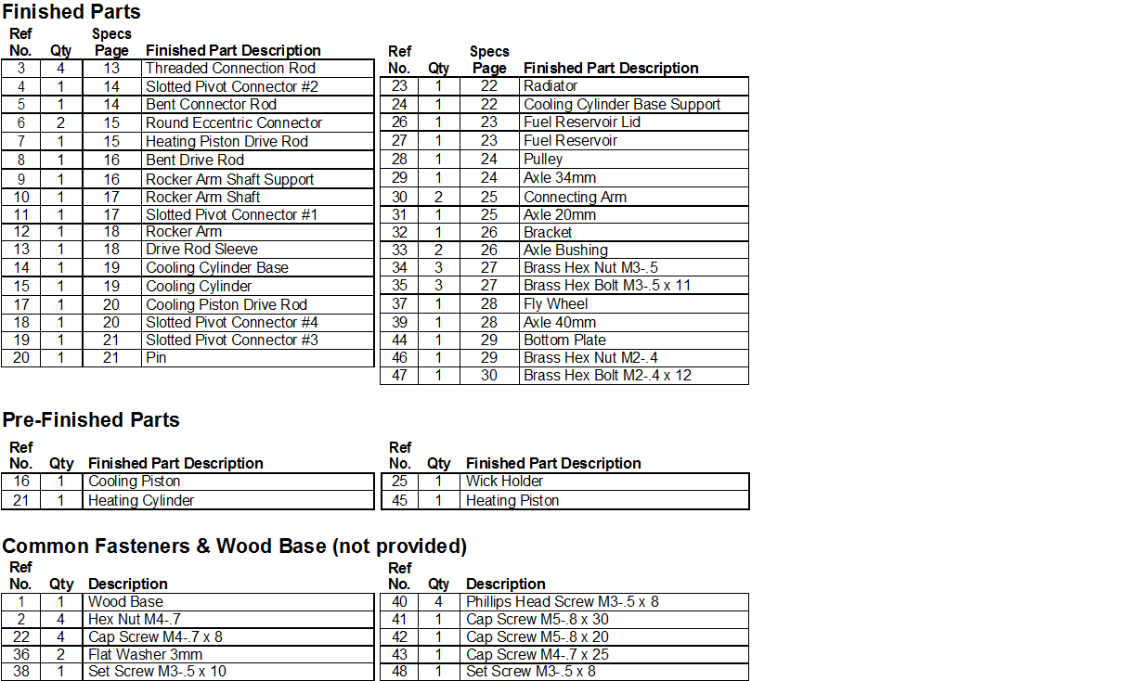

- Drilling the Vent Hole

For the internal air to move from the heating cyl-inder to the cooling cylinder, you must drill a ³⁄16" (5mm) vent hole at a 30° angle through the cool-ing cylinder base (Ref 14) and cooling cylinder (Ref 15) assembly.Firmly seat the cooling cylinder

- Positioning the Pistons

One piston needs to draw the air into its cylinder as the other piston pushes the air out of its cylin-der. This cooperative process is a significant part of the Stirling engine's efficiency. In order for the pistons to work together, assemble the linkage so that operating cycle of the pistons are directly opposite of one another.

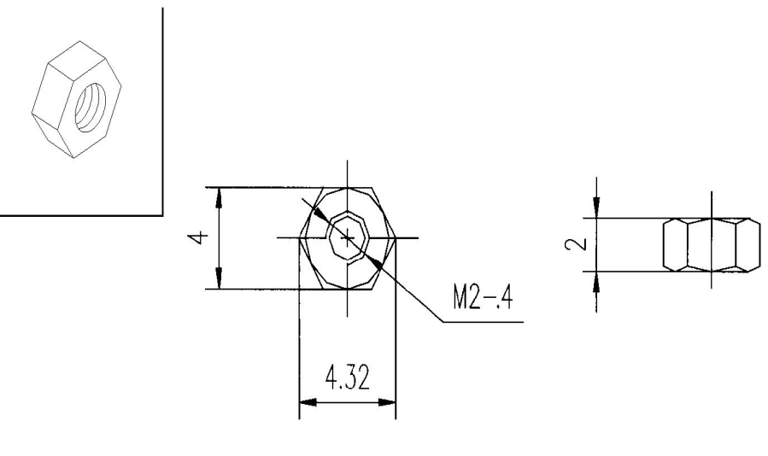
figure 20 hexa nut

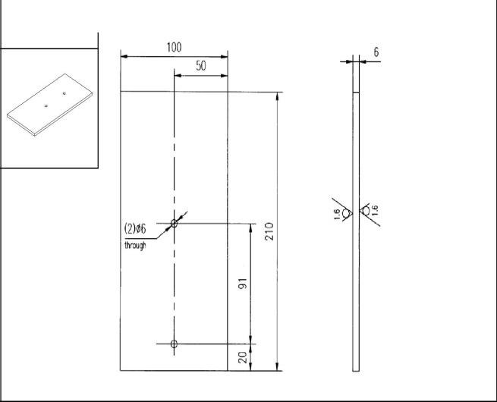

Figure 21 base plate
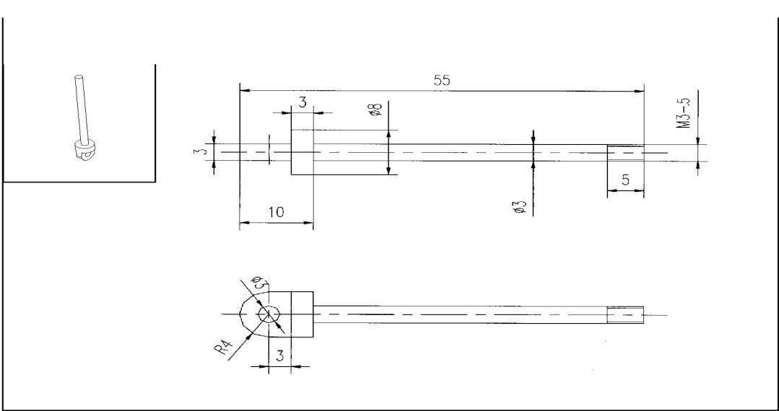

Figure 22 rocket arm shaft

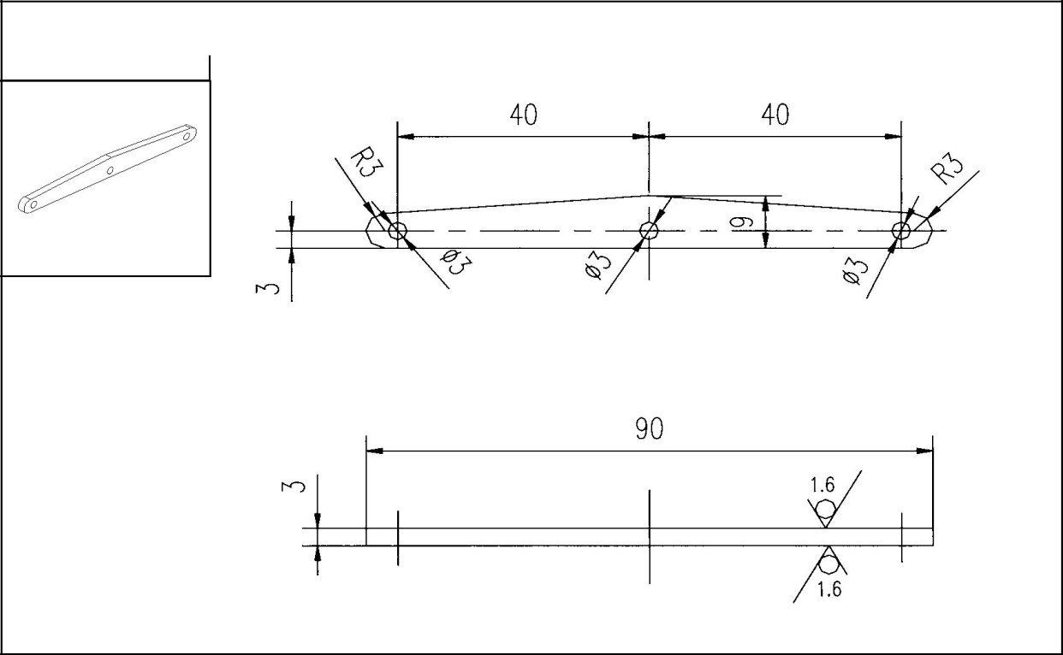
Figure 23 rocker arm

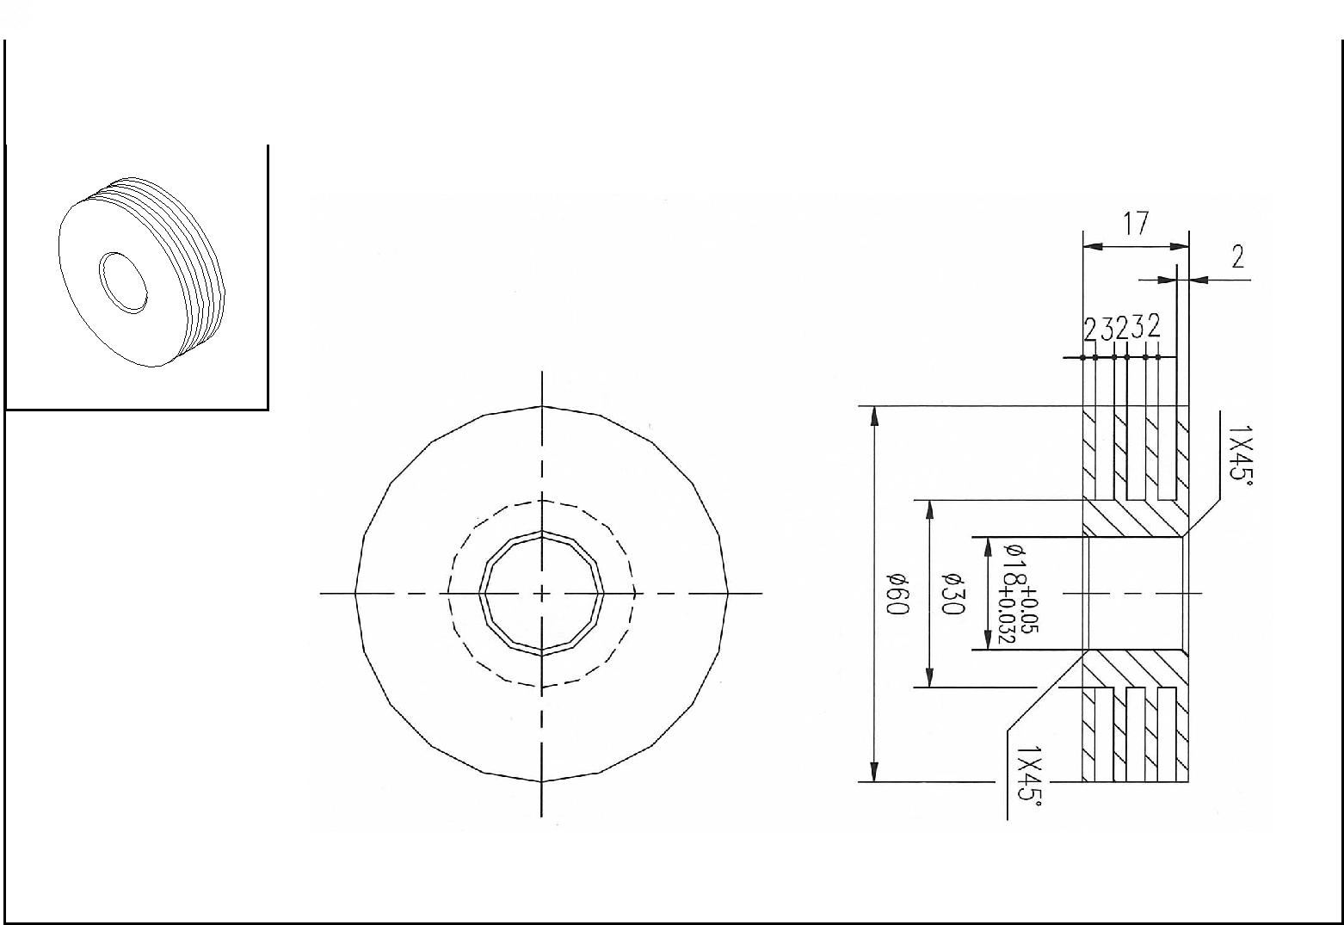

Figure 24 regenerator

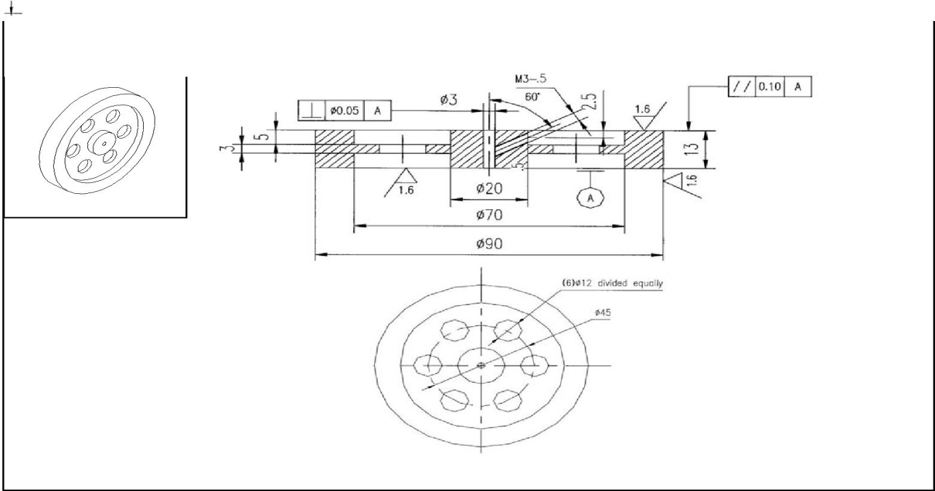
Figure 25 flywheel

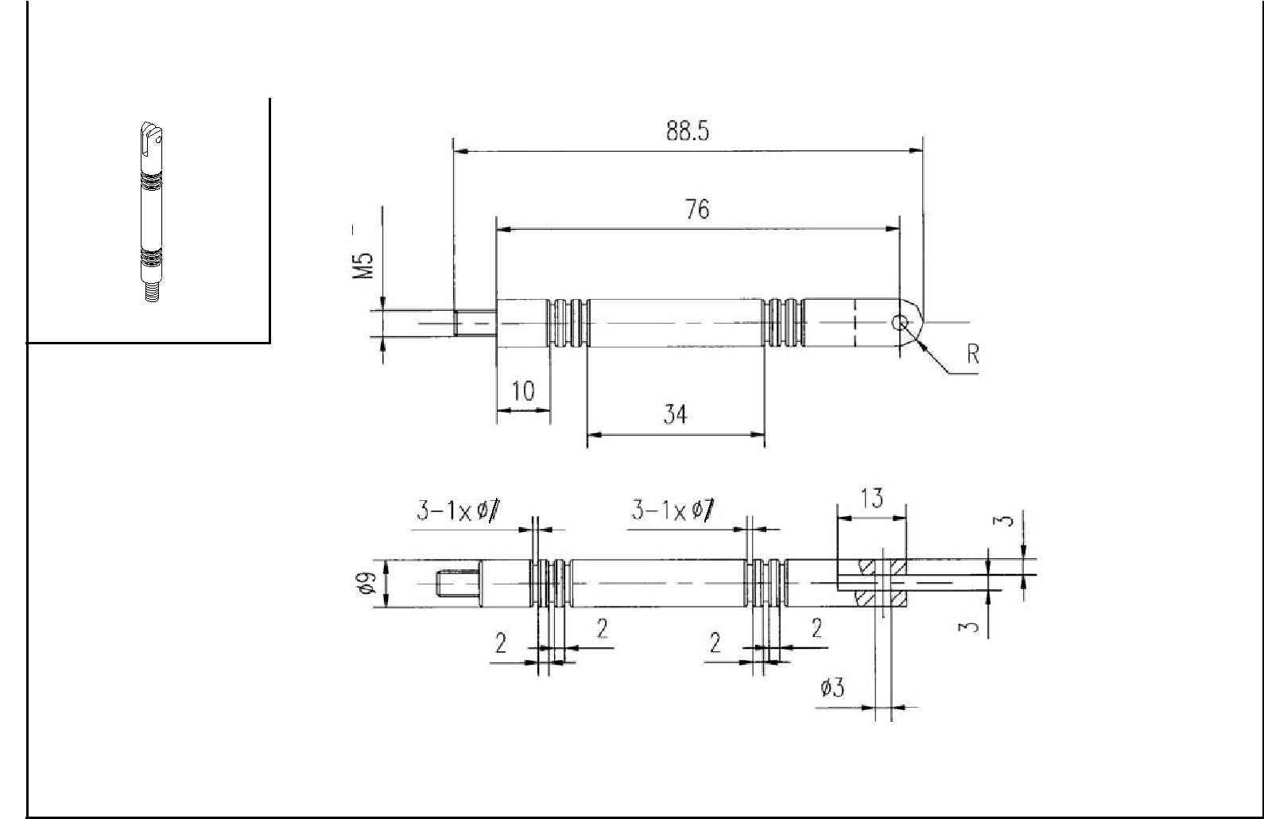
figure 26 ring support

CHAPTER 17. PROCESS CHARTS

Based on the different tests conducted on the engine has the following process charts :

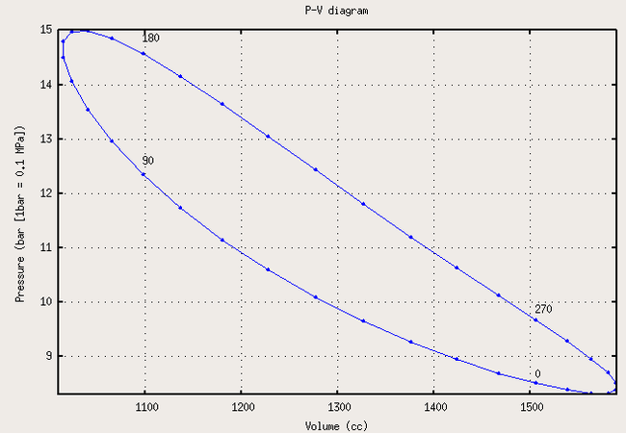
figure 27 pressure vs volume

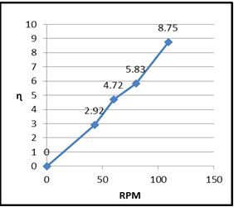
figure 28 efficiency vs rpm
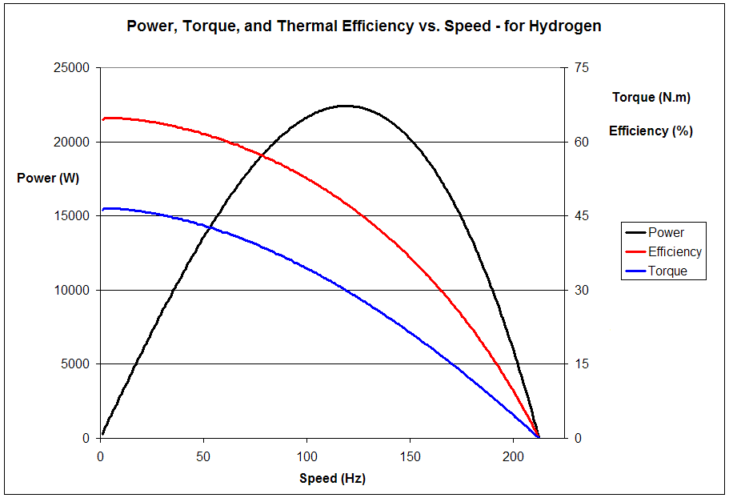
figure 29 power vs speed

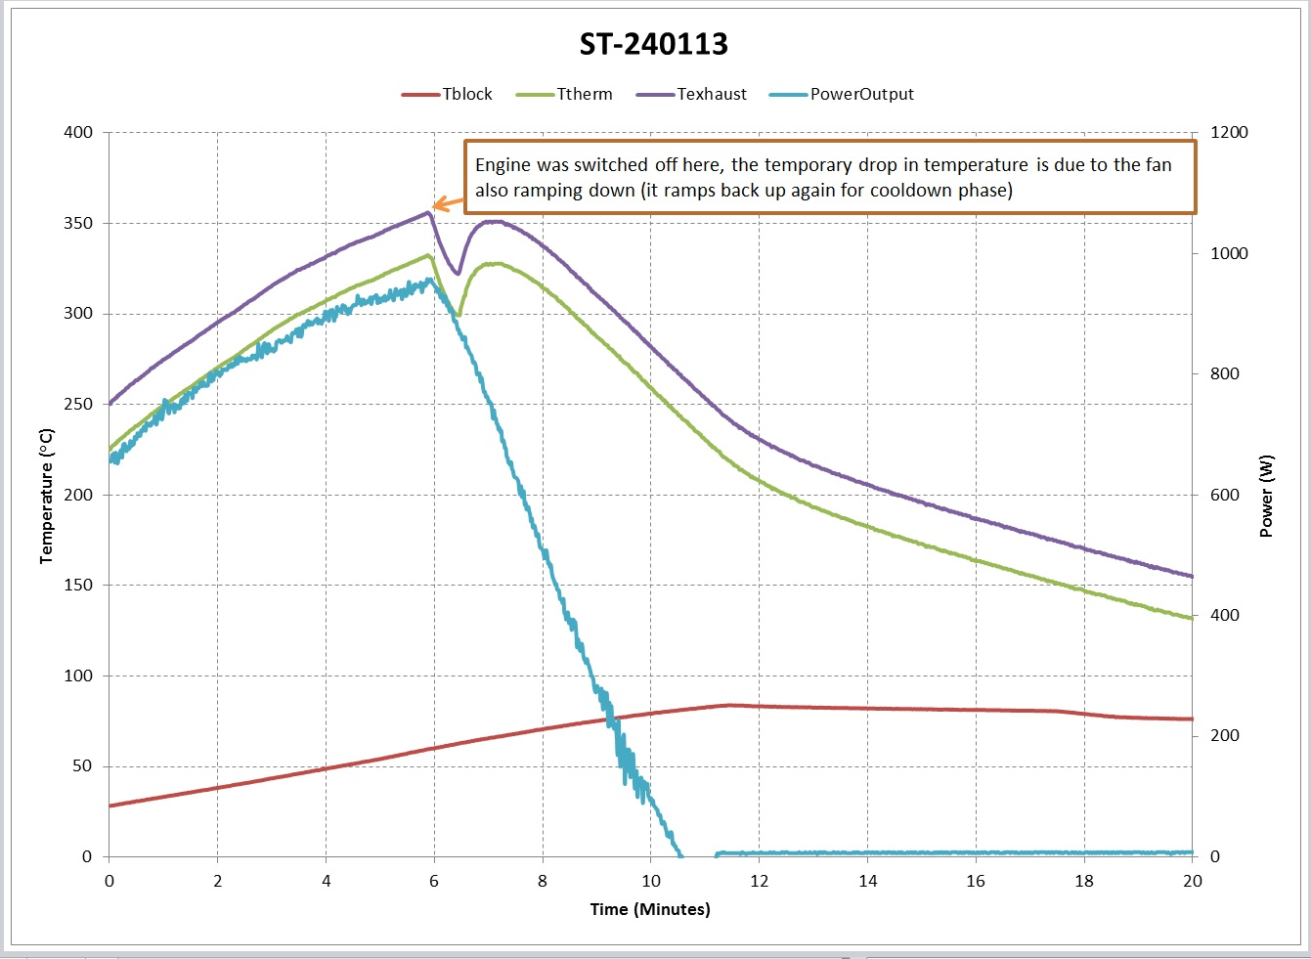
figure 30 temperature vs time
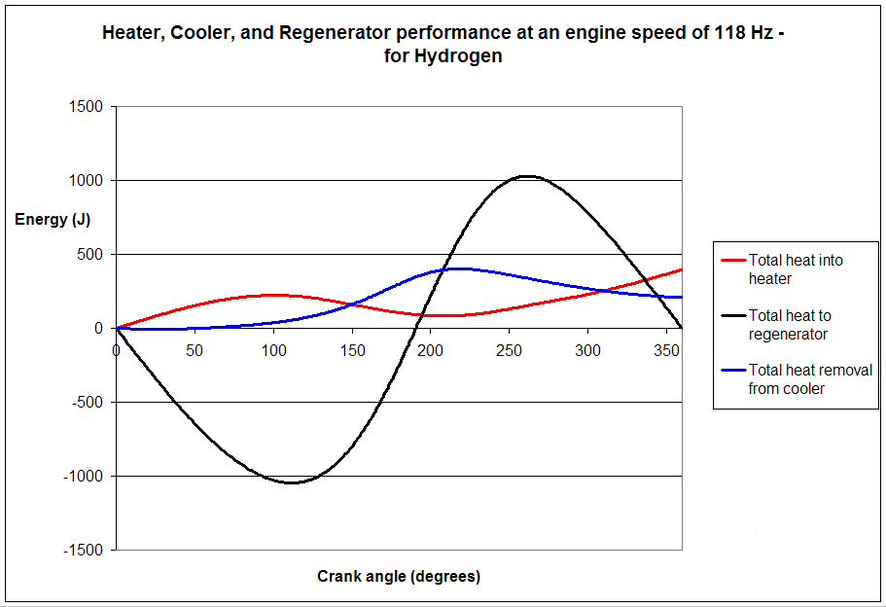
figure 31 energy vs crank angle
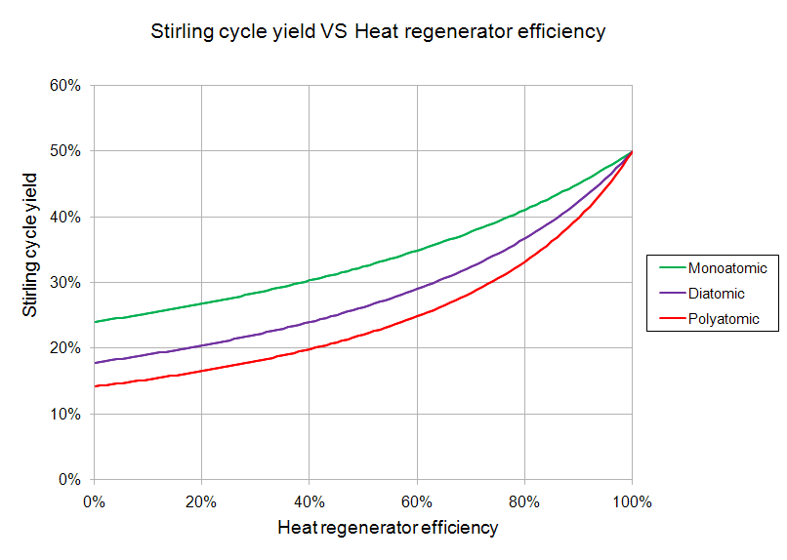
figure 32 energy vs efficiency
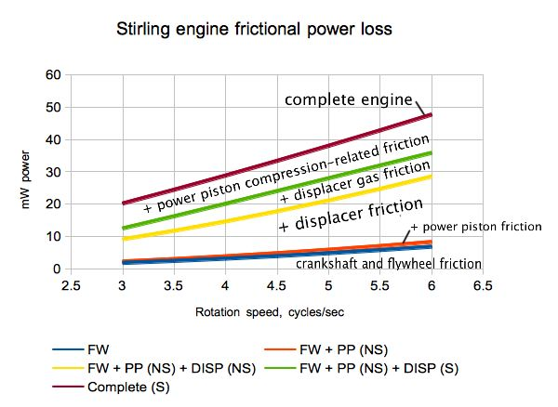
figure 33 power vs rotation speed

CHAPTER 18. CONCLUSION

18.1 REASONS TO USE A STIRLING ENGINE

- One reason is that for this kind of engine it’s almost impossible to explode. You don’t have to produce steam in a high pressure boiler. And inside the cylinder there are no explosions needed to run the pistons like in an Otto or Diesel engine.

- There are no ignitions, no carburetion because you only need one kind of gas and no valve train because there are no valves.

- This was a big advantage to the steam engines in the days when Stirling invented his engine because it was much less dangerous to work next to a Sterling Engine than to a common steam engine.

- Inside the pistons can be used air, helium, nitrogen or hydrogen and you don’t have to refill it because it uses always the same body of gas.

- The external combustion process can be designed as a continuous process, so the most types of emissions can be reduced.

- If heat comes from a renewable energy source they produce no emissions.

- They run very silent and they don’t need any air supply.

- They can be constructed to run very quiet and practically without any vibration.

- They can run with a small temperature difference, e.g. with the heat of your hand or from a cup of hot coffee. They can be used as little engines for work which needs only low power.

18.2 Analyze from Economic point

As said above the Stirling engine is a kind of external combustion engine, and it can use a variety of fuels. It can material, including gasoline, diesel, propane, sunshine and salad oil; even cow dung can be run on as fuels.

A cup of coffee cannot become a cup of gasoline, but it can be also used as a Stirling engine driver. There is a famous experiment that a Stirling engine can easily run on a cup of coffee. The Stirling engine is a kind of piston engine. In the heating sealed chamber, the expansion of gases inside the engine promotes the pistons work. After the expanded gases cooling down in the air
process is taking on. As long as a certain value of the temperature difference exists, a Stirling Engine can be formed.

This experiment shows that only a very small power operation can carry out a Stirling engine, which contributes a lot to especially shows out on economy point. The benefits obtained from the Stirling engine are definitely far beyond the costs.

So once solar is used to produce energy for surely be cut down for quite a lot. As long as there is sunshine, the Stirling engine willrun on and on. Of course it costs much to make Stirling Engine as it requires a high level of the materials and manufacturing processes. The expansion-side heat exchanger’s temperature is often very high, so the materials must stand the corrosive consequences of the heat. Typically these material requirements substantially increase the cost of the engine. The materials and assembly costs for a high temperature heat exchanger typically accounts for 40% of the total engine cost.

But once the Stirling engine is made and put into a proper condition, quite a few costs would be paid for keeping it running. Some engines cause a lot of pollution, so much is cost for pollution control and government. On contrast, Stirling engine exhausts cleanly and avoid this type of matter. Development and utilization of solar will not pollute the environment, as solar is one of the cleanest energy. While the environmental pollution is becoming more and more serious today, this characteristic is extremely valuable. It saves the cost for a lot while making sustainable development. At the end of 18th century and the early 19th century, heat engine generally is steam engine. Its efficiency is very low, only 3% to 5%, that is, over 95% of the heat is not used. Stirling thermodynamic theory is aiming to improve the thermal efficiency. Stirling proposed that the Stirling cycle efficiency, under the ideal condition, may get the infinite enhancement. Certainly it cannot come to 100% due to the physical limitation, however the theory provide a direction for improving the thermal efficiency. In fact, now the efficiency of Stirling engine can come up to 80% or even more. So another part of cost is saved.

Nowadays, more and more countries have recognized that a society with sustainable development should be able to meet the needs of the community without endangering future generations. Therefore, use clean energy as much as possible instead of the high carbon content of fossil energy is a principle which should be followed during energy construction. Vigorously develop new and renewable sources of energy utilization technology will be an important measure to reduce pollution.

Energy problem is a worldwide one, and it is sooner or later to get into the transition to- new-energy period. Because of its sustainability, renewably and efficiency, the Stirling engine is just the very one being consistent with the requirements of the times.

18.3 PROJECT CONCLUSION

- A small size stirling engine is used for effective power production(7-10volts)
- A large size and capacity gives correspondingly larger power.
- Particular heat source restriction is not there so fuel dependency is reduced.
- Even though output of engine is not sufficient to run a entire vehicle but it can be used as secondary engine in automobiles, and for all industrial light duty operations.
- It’s been proved that running cost of the engine is also very less this will help to minimize the usage of fuel and reduce air pollution.

This engine is very efficient because the heat is recycled many times inside the engine instead of used once and thrown away as in conventional engines.

Efficiency = energy we get out / energy we put in
This engine can be powered with the heat of a candle or concentrated sunlight. Some models will run on the heat of your hand. They will also run on the chemical processes that produce cold. The engine is usually silent unless a bearing is loose. The Stirling engine is the safest engine to work with. They can’t explode and most don’t put out enough energy to hurt human.

Even though output of engine is not sufficient to run a entire vehicle but it can be used as secondary engine in automobiles, and for all industrial light duty operations. Hence the objective of designing and manufacturing of engine was successful and can be implemented as a replacement to low power motors. It’s been proved that running cost of the engine is also very less this will help to minimize the usage of fuel and reduce air pollution.

Because, as companies look increasingly to alternative power units, it is entirely possible that the Stirling engine will find its own niche in the marketplace, perhaps as part of a hybrid power plant, or through further development andoptimization. No high-tech materials are needed. This competes with solar cells.

Taking one with another, Stirling engine bring a tremendous revolution to human being. We think there is also a lot of potential in this area because modern industrialization should be sustained by regenerate power system. It is not a dead end

REFERENCES

- Heat Recovery Systems by D.A.Reay, E & F.N.Span, London, 1979.

- Walker G. Stirling engines. Oxford: Clarendon Press, 1980.

- Senft JR. Ringbom Stirling engines. New York: Oxford University Press, 1993.

- Walpita SH. ,’Development of the Solar Receiver for a Small Stirling Engine’, Special study project report no. ET-83-1. Bangkok: Asian Institute of Technology; 1983.

- Shah Alam. A proposed Model for Utilizing Exhaust Heat to run Automobile Air conditioner. International Conference on “ Sustainable Energy and Environment(SEE 2006)”.

- "Stirling Engines", G. Walker (1980), Clarenden Press, Oxford, page 1: "A

- W.R. Martini (1983), p.6

- T. Finkelstein; A.J. Organ (2001), Chapters 2&3

- Stirling engines capable of reaching 40% efficiency

- Sleeve notes from A.J. Organ (2007

BIBLIOGRAPHY

In order to accomplish the current project, the following web pages have been consulted. The authors of the project would like to thank the following for their accuracy, clarity and conciseness.

http://en.wikipedia.org/wiki/Stirling_engine
• http://www.kockums.se
• http://www.grc.nasa.gov/
• http://www.infiniacorp.com/main.htm
• http://www.stirlingenergy.com
• http://www.whispergen.com/index.cfm
• http://www.sunpower.com/index.php
• http://www.sesusa.org/index.html
• http://news.soliclima.com
• http://www.nrel.gov/csp
• http://www.cec.uchile.cl/~roroman/
• http://www.stirlingengine.com
• www.blog.steamshift.com
• www.techfreep.com
• www.sensi.org
• www.energytech.at
• www.Sterlingenergy.com
• www.Stirlingengine.com
• www.logicsys.com.tw/wrkbas.htm.

